ASSIGNMENT

Q1. create a html page using basic tags.

<!DOCTYPE html>

<html>

<head>

<title> environment </title>

<body>

</html>

<h1> The environment gives us countless benefits that we can't repay our entire life. </h1>

<h2> As they are connected with the forest, trees, animals, water, and air. </h2>

<h3> The forest and trees filter the air and absorb harmful gases. </h3>

<h4> Plants purify water, reduce the chances of flood maintain natural balance and many others. </h4>

<h5> The environment provides us fertile land, water, air, livestock and many essential things for survival. </h5>

<h6> It regulates the vital systems that are essential for the ecosystem. </h6>

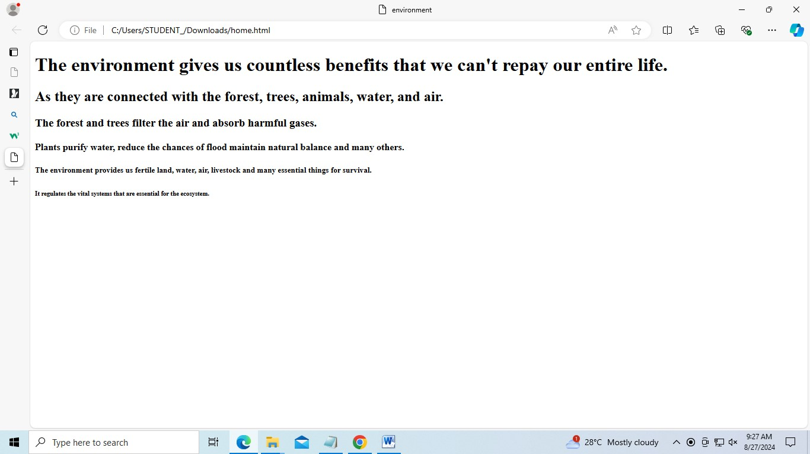

Q2. create a page that displays your name to the screen.

<html>

<head>

<title> my first html page </title>

</head>

<body>

<h1>"SNEHA SIDHU"</h1>

</body>

</html>

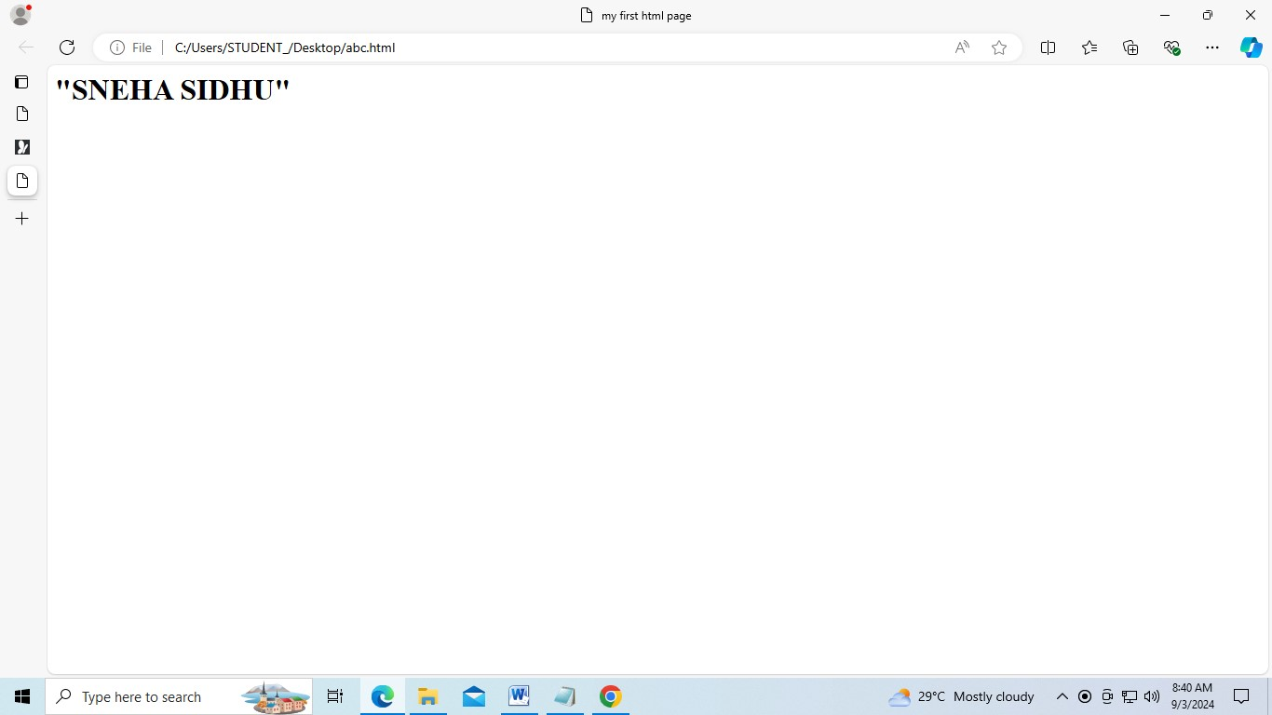

Q3. create a webpage and show the output from 1 to 10 in separate lines.

<html>

<head>

<title> numbers 1 to 10 </title>

</head>

<body>

1<br>

2<br>

3<br>

4<br>

5<br>

6<br>

7<br>

8<br>

9<br>

10

</body>

</html>

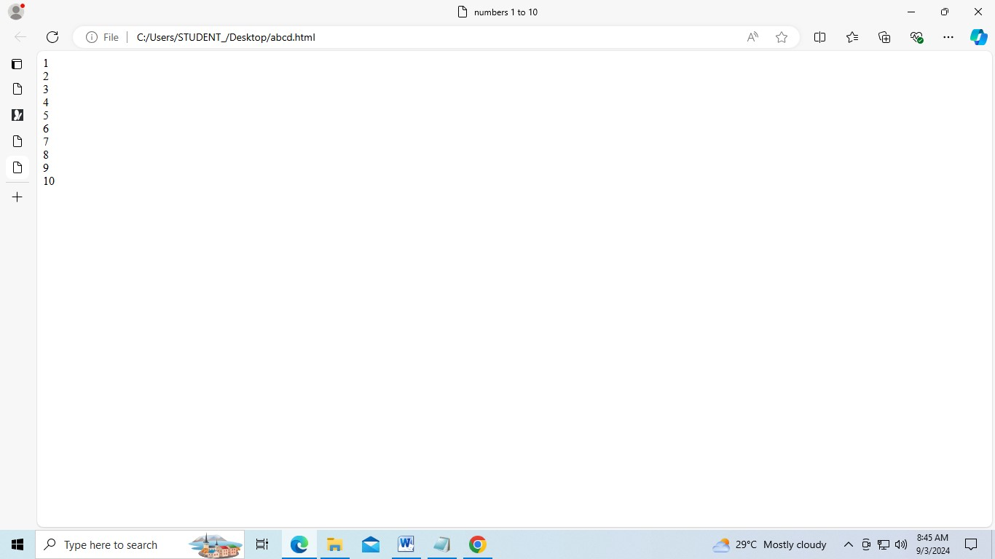

Q4. create a web page and show the output 1 to 10 in separate lines, each number being in different color.

<html>

<head>

<title>number colors</title>

</head>

<body>

<font color="red">1</font><br>

<font color="orange">2</font><br>

<font color="yellow">3</font><br>

<font color="green">4</font><br>

<font color="blue">5</font><br>

<font color="indigo">6</font><br>

<font color="violet">7</font><br>

<font color="pink">8</font><br>

<font color="brown">9</font><br>

<font color="grey">10</font><br>

</body>

</html>

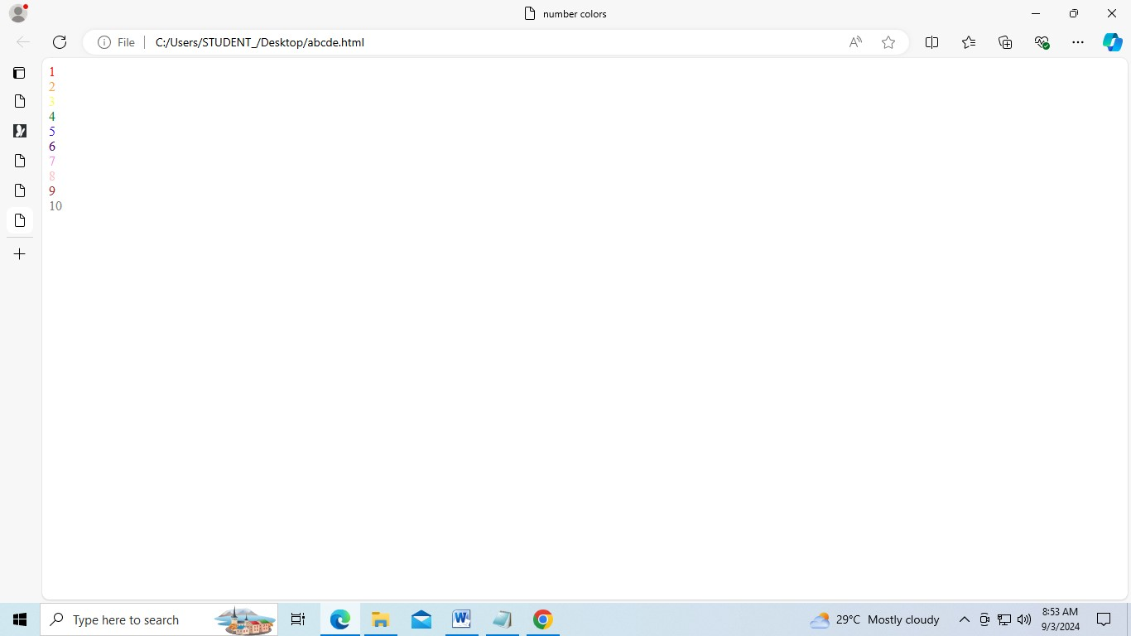

Q5. how do I make a picture as a background on my pages?

<html>

<head>

<title> background image </title>

</head>

</body>

<body

background="[https://as2.ftcdn.net/v2/jpg/05/68/98/15/1000_F_568981524_2irG4VUSs06xbahAihTpku SfxKkw8FqX.jpg](https://as2.ftcdn.net/v2/jpg/05/68/98/15/1000_F_568981524_2irG4VUSs06xbahAihTpkuSfxKkw8FqX.jpg) ["](https://as2.ftcdn.net/v2/jpg/05/68/98/15/1000_F_568981524_2irG4VUSs06xbahAihTpkuSfxKkw8FqX.jpg)>

</body>

</html>



Q6 create a web page to print a paragraph with 4-5 sentence, each sentences shall have a different font?

<HTML>

<head>

<title>paragraph with different fonts</title>

</head>

<body>

<h1>SNEHA SIDHU </h1>

<p>

<B>my name is Sneha Sidhu.</B><br>

<I>i am studying at manav rachna institute of internationls reserch and studies pursuing bca ai ml it is situated in faridabad,india</I><br>

<U>i am looking forward to become ai engineer and my course suits my goals perfectly </U><br>

<B>my hobbies are doing editing in my free time and playing badminton on weekends</B></br> </p>

</body>

</html>

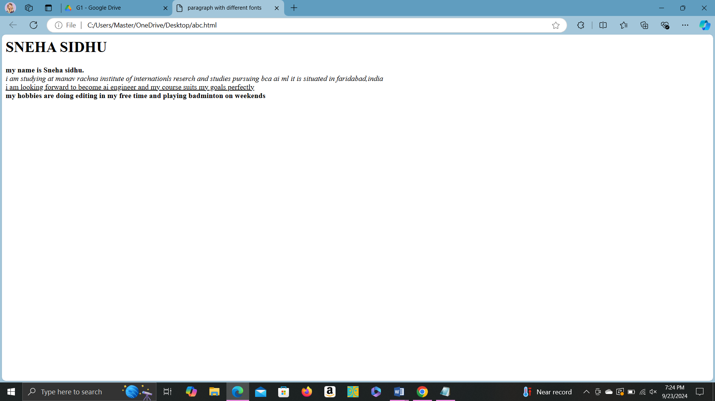

Q7 write a html code to print a paragraph that is a description book, it shall include the title of the book, its author name; name and title should be underlined and all adjectives shall be in bold italics

<html>

<head>

<title>Book Description</title>

</head>

<body>

<h1><u><B>The Great Gatsby</u></B></h1>

<p>AUTHOR NAME:<u>F.Scott Fitzgerald</u><br>

The Great Gatsby is a <B>classic novel</B> set in the <i>roaring</i> 1920s. It explores the

<B>glamorous</B> and <B>decadent</B> lifestyles of the era through the eyes of the

<i>mysterious</i >and wealthy Jay Gatsby. The story delves into themes of <B>unrequited love</B>, moral decay, and the <i>elusive nature</i> of the American Dream.</p>

</body>

</html>

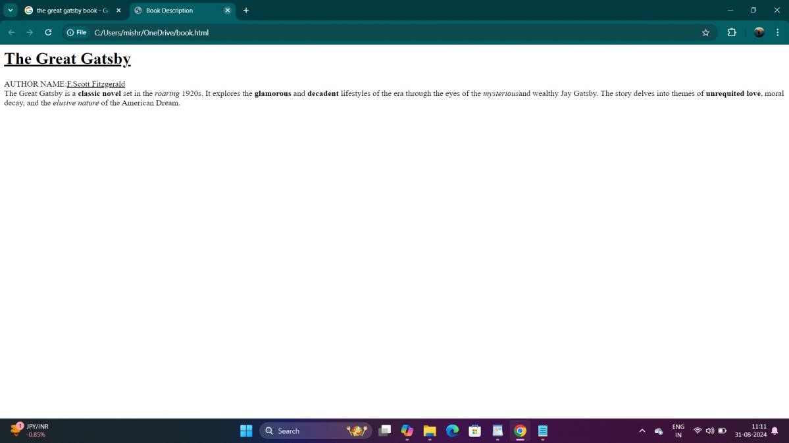

Q8 write a html code to print name using heading tag, every letter shall be in different heading size

<html>

<head>

<title>Name in Different Heading Sizes</title>

</head>

<body>

<h1>A</h1>

<h2>b</h2>

<h3>h</h3>

<h4>i</h4>

<h5>n</h5>

<h6>a</h6>

<h1>v</h1>

<h2> </h2> <!-- Space between names -->

<h3>M</h3>

<h4>i</h4>

<h5>s</h5>

<h6>h</h6>

<h1>r</h1>

<h2>a</h2>

</body>

</html>

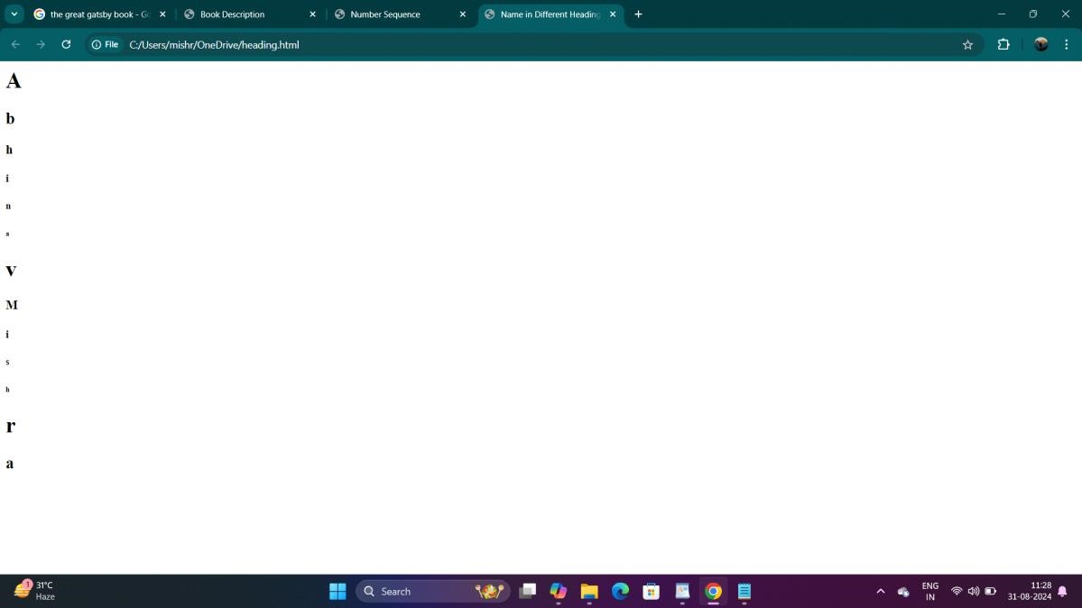

Q9 write html code to print the sequence of numbers 1-20. each number shall be in different line with number 2 next to it as subscript, an equal sign and the result.

<html>

<head>

<title>Number Sequence</title>

</head>

<body>

<p>1<sub>2</sub> = 1</p>

<p>2<sub>2</sub> = 4</p>

<p>3<sub>2</sub> = 9</p>

<p>4<sub>2</sub> = 16</p>

<p>5<sub>2</sub> = 25</p>

<p>6<sub>2</sub> = 36</p>

<p>7<sub>2</sub> = 49</p>

<p>8<sub>2</sub> = 64</p>

<p>9<sub>2</sub> = 81</p>

<p>10<sub>2</sub> = 100</p>

<p>11<sub>2</sub> = 121</p>

<p>12<sub>2</sub> = 144</p>

<p>13<sub>2</sub> = 169</p>

<p>14<sub>2</sub> = 196</p>

<p>15<sub>2</sub> = 225</p>

<p>16<sub>2</sub> = 256</p>

<p>17<sub>2</sub> = 289</p>

<p>18<sub>2</sub> = 324</p>

<p>19<sub>2</sub> = 361</p>

<p>20<sub>2</sub> = 400</p>

</body>

</html>

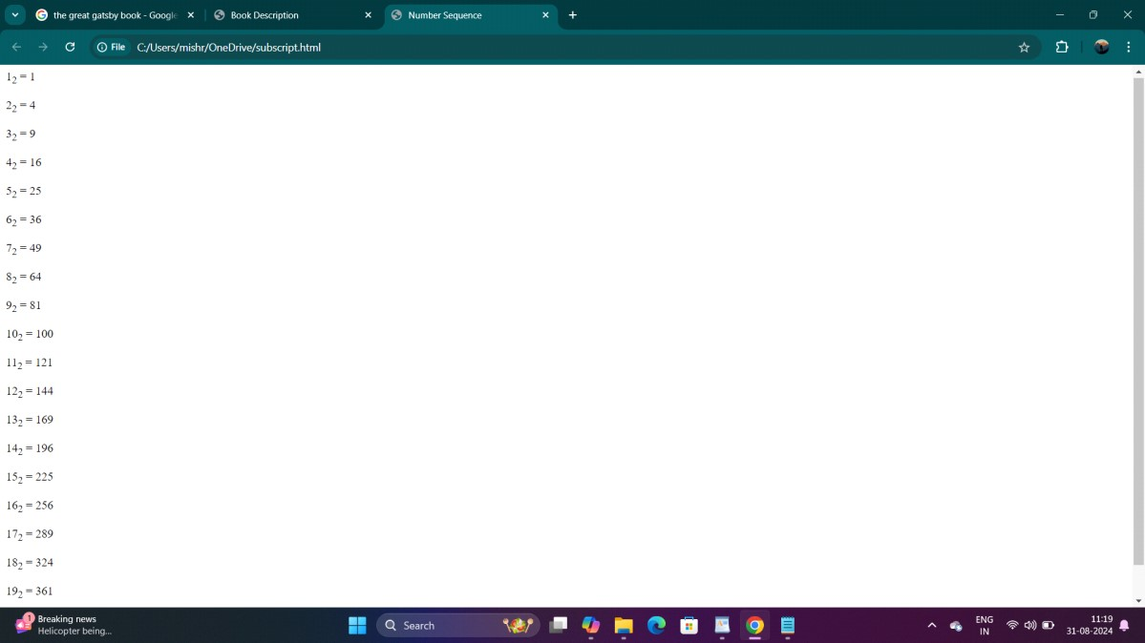

Q 10 write a html code to display an image with border of size with width 200 height 200 pixels, leaving H Space and V Space of your choice with image hanging in the right side on the screen.

:- <HTML>

<head>

<title>Image Display</title>

<style> img { border: 2px solid black; width: 200px; height: 200px; display: block; margin-left: auto; margin-right: 0; margin-top: 20px; margin-bottom: 20px; }

</style>

</head>

<body>

<img src="https://m.media-amazon.com/images/I/81o8PrHjBqL._AC_UF1000,1000_QL80_.jpg" alt="Sample Image">

</body>

</html>

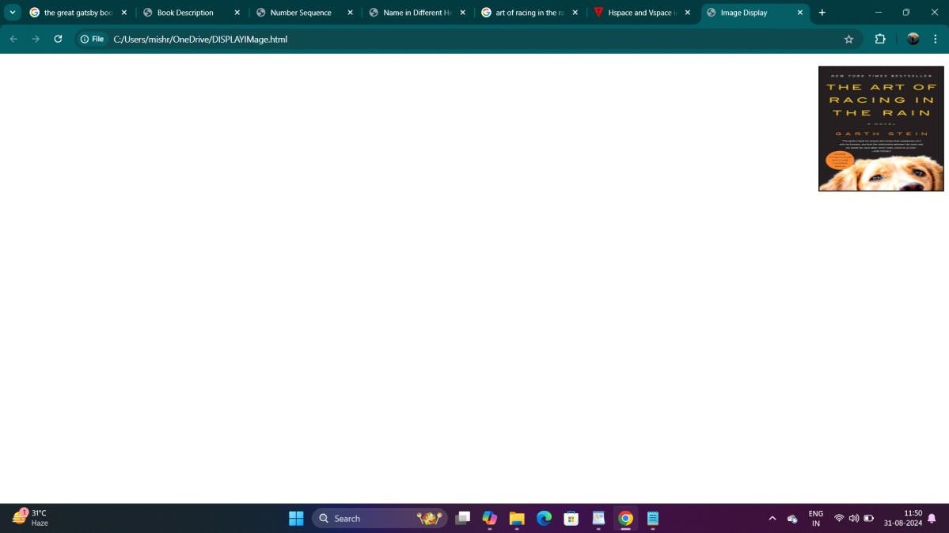

Q 11 write a html code to create a web page with heading. the heading shall be displayed at the top-center of the page and the image shall be at the center, just below the heading.

<html>

<head>

<title>Centered Heading and Image</title>

<style> body { margin: 0; font-family: Arial, sans-serif; text-align: center; justify-content: center; align-items: center;

</style>

</head>

<body>

<h1>The Triumph of India 2024</h1>

<img src="https://www.financialexpress.com/wp-content/uploads/2024/06/T20-World-Cup-2024-1.jpg" alt="T20 World Cup 2024">

</body>

</html>

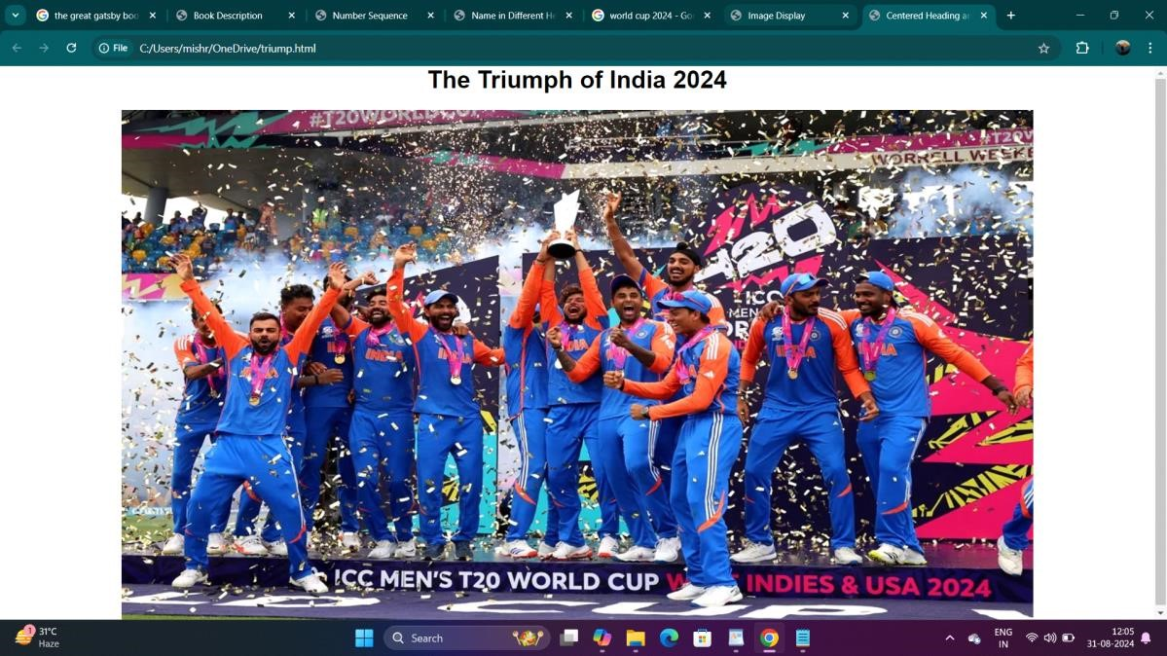

Q12 Write HTML code using Multimedia tags.

<html>

<head>

<title>Multimedia Example</title>

</head>

<body>

<h2>Image Example</h2>

<img src="C:\Users\HP\OneDrive\Desktop\scenry" alt="Beautiful Scenery" width="500">

<!-- Embedding a video -->

<h2>Video Example</h2>

<video width="500" controls>

<source src="C:\Users\HP\OneDrive\Desktop\scenery video" type="video/mp4">

</video>

<!-- Embedding audio -->

<h2>Audio Example</h2>

<audio controls>

<source src="sample-audio.mp3" type="audio/mpeg"

</audio>

</body>

</html>

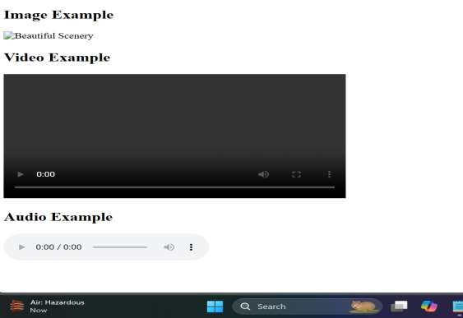

Q13 Create a Table using Rowspan and Colspan taking example of student Record.

<html>

<head>

<title>Student Record</title>

<style> table { width: 80%; border-collapse: collapse; margin: 20px auto;

} th, td {

border: 1px solid #000; padding: 8px; text-align: center;

}

</style>

</head>

<body>

<table>

<tr>

<th rowspan="2">Student ID</th>

<th rowspan="2">Name</th>

<th colspan="3">Subjects</th>

</tr>

<tr>

<th>Math</th>

<th>Science</th>

<th>English</th>

</tr>

<tr>

<td>1</td>

<td>Riya</td>

<td>85</td>

<td>90</td>

<td>78</td>

</tr>

<tr>

<td>2</td>

<td>Priya</td>

<td>88</td>

<td>92</td>

<td>80</td>

</tr>

</table>

</body>

</html>

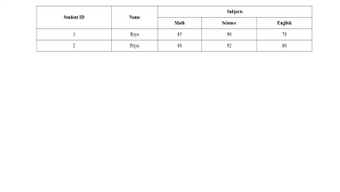

Q14 Write HTML code using table tag <table> and cellpadding and cellspacing as its attributes.

<html>

<head>

<title>Student Record Table</title>

<style> table {

border: 1px solid #000; margin: 20px auto; border-collapse: collapse;

} th, td {

border: 1px solid #000;

padding: 10px; text-align: center;

}

</style>

</head>

<body>

<table cellpadding="10" cellspacing="5">

<tr>

<th>Student ID</th>

<th>Name</th>

<th>Math</th>

<th>Science</th>

<th>English</th>

</tr>

<tr>

<td>1</td>

<td>Riya</td>

<td>85</td>

<td>90</td>

<td>78</td>

</tr>

<tr>

<td>2</td>

<td>Zaen</td>

<td>88</td>

<td>92</td>

<td>80</td>

</tr>

</table>

</body>

</html>

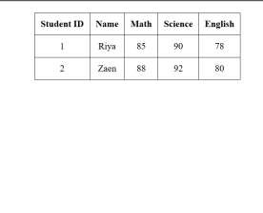

Q15 Create unordered, ordered and definition Lists taking example of your subjects in MCA IST, IInd and IIIrd Semester.

<html>

<head>

<title>MCA Subjects</title>

</head>

<body>

<h1>MCA IST Subjects</h1>

<!-- Unordered List -->

<h2>IInd Semester Subjects</h2>

<ul>

<li>Database Management Systems</li>

<li>Data Structures and Algorithms</li>

<li>Software Engineering</li>

<li>Web Technologies</li>

</ul>

<!-- Ordered List -->

<h2>IIIrd Semester Subjects</h2>

<ol>

<li>Operating Systems</li>

<li>Computer Networks</li>

<li>Mobile Application Development</li> <li>Artificial Intelligence</li>

</ol>

<!-- Definition List -->

<h2>Subject Definitions</h2>

<dl>

<dt>Database Management Systems</dt>

<dd>A system for creating and managing databases.</dd>

<dt>Data Structures and Algorithms</dt>

<dd>The study of data organization and the algorithms that operate on them.</dd>

<dt>Software Engineering</dt>

<dd>The application of engineering principles to software development.</dd>

<dt>Web Technologies</dt>

<dd>Technologies used for developing web applications.</dd>

<dt>Operating Systems</dt>

<dd>The software that manages computer hardware and software resources.</dd>

<dt>Computer Networks</dt>

<dd>The study of interconnecting computers to share resources.</dd>

<dt>Mobile Application Development</dt>

<dd>The process of creating software applications for mobile devices.</dd>

<dt>Artificial Intelligence</dt>

<dd>The simulation of human intelligence processes by machines.</dd>

</dl>

</body>

</html>

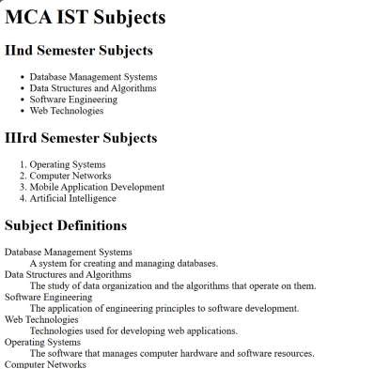

Q16 Write HTML code using <frameset> and <frame> tag with all its attributes

<html>

<head>

<title>Frameset Example</title>

</head>

<frameset rows="50%,50%" border="2" frameborder="yes" framespacing="5">

<frame src="header.html" name="header" scrolling="no" noresize>

<frame src="content.html" name="content" scrolling="yes"> </frameset>

<noframes>

<body>

<p>Your browser does not support frames. Please consider updating your browser.</p>

</body>

</noframes>

</html>

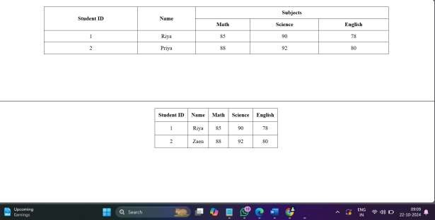

Q17 Write HTML code to design a form in HTML using controls and buttons such as Teaxtbox, Textarea

<html>

<head>

<title>Sample Form</title>

<style> body {

font-family: Arial, sans-serif; margin: 20px;

}

form {

max-width: 400px; margin: auto;

} label { display: block; margin-top: 10px;

}

input, textarea, select { width: 100%; padding: 8px; margin-top: 5px; box-sizing: border-box;

}

button { margin-top: 10px; padding: 10px; background-color: #4CAF50; color: white; border: none; cursor: pointer;

}

button:hover { background-color: #45a049;

}

</style>

</head>

<body>

<h1>Feedback Form</h1>

<form action="/submit" method="post">

<label for="name">Name:</label> <input type="text" id="name" name="name" \>

<label for="email">Email:</label>

<input type="email" id="email" name="email" \>

<label for="feedback">Feedback:</label>

<textarea id="feedback" name="feedback" rows="4" ></textarea>

<label>Preferred Contact Method:</label>

<input type="radio" id="phone" name="contact" value="phone">

<label for="phone">Phone</label>

<input type="radio" id="email_contact" name="contact" value="email" checked>

<label for="email_contact">Email</label>

<label>Subscribe to Newsletter:</label>

<input type="checkbox" id="subscribe" name="subscribe" value="yes">

<label for="subscribe">Yes, I want to receive updates</label>

<button type="submit">Submit</button>

</form>

</body>

</html>

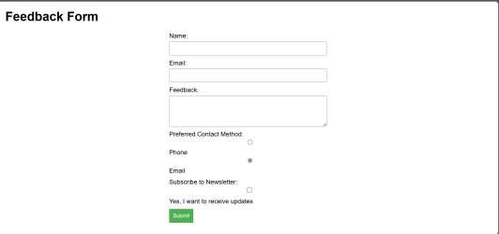

Q18 Write HTML code to design a Registration Form in HTML.

<html>

<head>

<title>Registration Form</title>

<style> body {

font-family: Arial; margin: 20px; background-color:White;

}

form { max-width: 500px; margin: auto; background: white; padding: 20px; border-radius: 5px; box-shadow: 0 0 10px

} label { display: block; margin-top: 10px;

}

input, select, textarea { width: 100%; padding: 8px; margin-top: 5px; box-sizing: border-box;

}

button { margin-top: 10px; padding: 10px; background-color:Black; color: white; border: none; cursor: pointer; width: 100%;

}

button:hover { background-color: Blue;

}

</style>

</head>

<body>

<h1>Registration Form</h1>

<form action="/submit" method="post">

<label for="username">Username:</label>

<input type="text" id="username" name="username" required>

<label for="email">Email:</label>

<input type="email" id="email" name="email" required> <label for="password">Password:</label>

<input type="password" id="password" name="password" required>

<label for="confirm-password">Confirm Password:</label>

<input type="password" id="confirm-password" name="confirm-password" required>

<label for="dob">Date of Birth:</label>

<input type="date" id="dob" name="dob" required>

<label for="gender">Gender:</label>

<select id="gender" name="gender" required>

<option value="">Select Gender</option>

<option value="male">Male</option>

<option value="female">Female</option>

<option value="other">Other</option>

</select>

<label for="address">Address:</label>

<textarea id="address" name="address" rows="4" required></textarea>

<label for="phone">Phone Number:</label>

<input type="tel" id="phone" name="phone" required>

<button type="submit">Register</button>

</form>

</body>

</html>

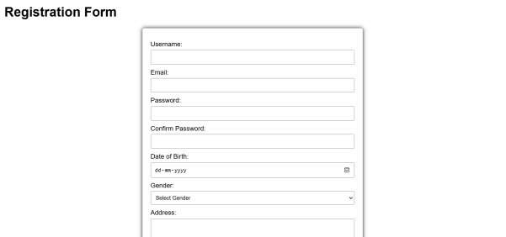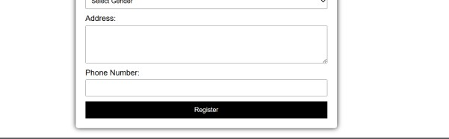

Q19 Write HTML code to design a student admission Form in HTML.

<html>

<head>

<title>Student Admission Form</title>

<style> body { font-family: Arial; margin: 20px; background-color: Green;

}

form { max-width: 600px; margin: auto; background: white; padding: 20px; border-radius: 5px; box-shadow: 0 0 10px ;

} label { display: block; margin-top: 10px;

}

input, select, textarea { width: 100%; padding: 8px; margin-top: 5px; box-sizing: border-box;

}

button { margin-top: 10px; padding: 10px; background-color: White; color: white; border: none; cursor: pointer; width: 100%;

}

button:hover { background-color:Red;

}

</style>

</head>

<body>

<h1>Student Admission Form</h1>

<form action="/submit" method="post">

<label for="fullName">Full Name:</label>

<input type="text" id="fullName" name="fullName" \>

<label for="dob">Date of Birth:</label>

<input type="date" id="dob" name="dob" \>

<label for="gender">Gender:</label>

<select id="gender" name="gender" \>

<option value="">Select Gender</option>

<option value="male">Male</option>

<option value="female">Female</option>

<option value="other">Other</option>

</select>

<label for="address">Address:</label>

<textarea id="address" name="address" rows="4" ></textarea>

<label for="email">Email:</label>

<input type="email" id="email" name="email" \> <label for="phone">Phone Number:</label>

<input type="Number" id="phone" name="phone" \>

<label for="course">Course Applied For:</label>

<select id="course" name="course" required>

<option value="">Select Course</option>

<option value="bsc">B.Sc</option>

<option value="msc">M.Sc</option>

<option value="bcom">B.Com</option>

<option value="mcom">M.Com</option>

<option value="bca">BCA</option>

<option value="mca">MCA</option>

</select>

<label for="previousSchool">Previous School/College:</label>

<input type="text" id="previousSchool" name="previousSchool" required>

<label for="academicYear">Academic Year:</label>

<select id="academicYear" name="academicYear" required>

<option value="">Select Academic Year</option>

<option value="2024">2024</option>

<option value="2025">2025</option>

<option value="2026">2026</option>

</select>

<button type="submit">Submit Application</button>

</form>

</body>

</html>

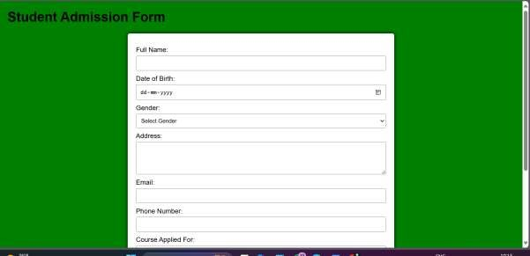

Q20 Create a proper home page of your own using any components and styles.

<html>

<head>

<title>My Homepage</title>

<style> body {

font-family: Arial; margin: 0; padding: 0; background-color:White;

}

header { background:White; color: white; padding: 10px 0; text-align: center;

} nav { margin: 0; padding: 10px 0;

}

nav a { color: white; margin: 0 15px; text-decoration: none; font-weight: bold;

}

nav a:hover { text-decoration: underline;

}

.hero { height: 400px; display: flex; align-items: center; justify-content: center; color: white; text-shadow: 2px 2px 4px;

}

.hero h1 { font-size: 3em;

}

.container { padding: 20px;

}

.section { margin: 20px 0; padding: 20px; background: white; border-radius: 5px; box-shadow: 0 0 10px;

}

footer { background: Red; color: white; text-align: center; padding: 10px 0; position: relative; bottom: 0; width: 100%;

}

</style>

</head>

<body>

<header>

<h1>Welcome to My Homepage</h1>

<nav>

<a href="#about">About</a>

<a href="#services">Services</a>

<a href="#contact">Contact</a>

</nav>

</header>

<div class="hero">

<h1>Your Journey Begins Here</h1>

</div>

<div class="container">

<div id="about" class="section">

<h2>About Me</h2>

<p>Hello! I am a web developer with a passion for creating beautiful and functional websites. I love coding and constantly learning new technologies.</p>

</div>

<div id="services" class="section">

<h2>Services</h2>

<ul>

<li>Web Development</li>

<li>UI/UX Design</li>

<li>SEO Optimization</li>

<li>Content Creation</li>

</ul>

</div>

<div id="contact" class="section">

<h2>Contact Me</h2>

<p>If you would like to get in touch, feel free to reach out via email at <a

href="mailto:example@example.com">example@example.c om</a>.</p>

</div>

</div>

<footer>

<p>&copy; 2024 My Homepage. All rights reserved.</p>

</footer>

</body>

</html>

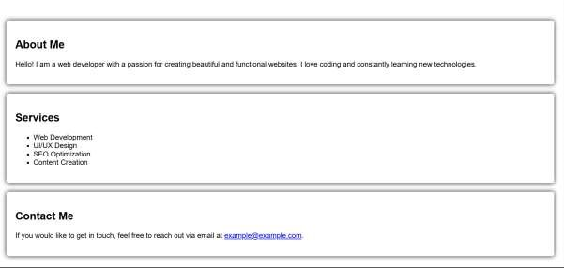

Q21 Write HTML code for including Local hyperlinking in a web page.

<html>

<head>

<title>Local Hyperlinking Example</title>

<style> body {

font-family: Arial, sans-serif; margin: 20px;

}

section {

margin-bottom: 40px;

}

</style>

</head>

<body>

<h1>Local Hyperlinking Example</h1>

<ul>

<li><a href="#section1">Go to Section 1</a></li>

<li><a href="#section2">Go to Section 2</a></li> <li><a href="#section3">Go to Section 3</a></li>

</ul>

<section id="section1">

<h2>Section 1</h2>

<p>This is the content of section 1.</p>

<a href="#top">Back to Top</a>

</section>

<section id="section2">

<h2>Section 2</h2>

<p>This is the content of section 2.</p>

<a href="#top">Back to Top</a>

</section>

<section id="section3">

<h2>Section 3</h2>

<p>This is the content of section 3.</p>

<a href="#top">Back to Top</a>

</section>

</body>

</html>

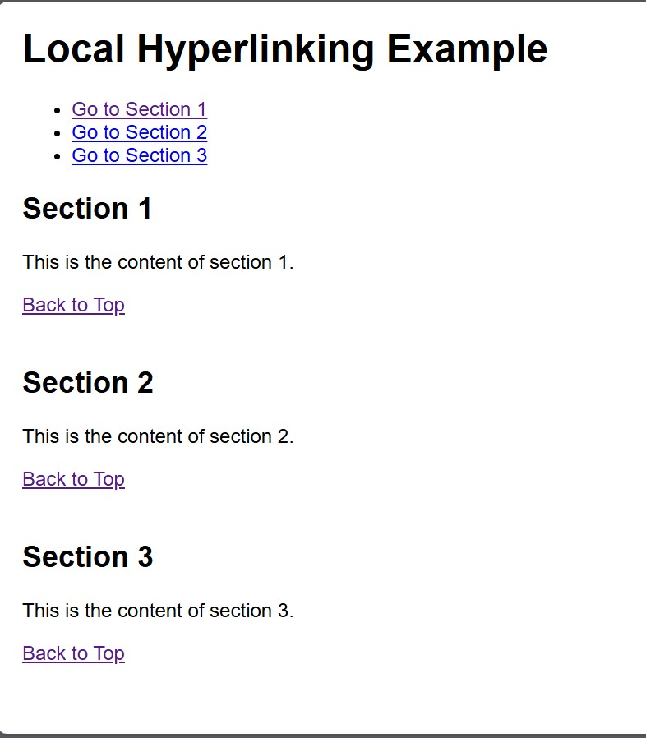

Q22 Write HTML code for including Inter hyperlinking in a web page.

<html>

<head>

<title>Interlinking Example</title>

<style> body {

font-family: Arial, sans-serif;

}

section { margin: 20px 0;

} nav {

margin-bottom: 20px;

}

</style>

</head>

<body>

<nav>

<ul>

<li><a href="#section1">Go to Section 1</a></li>

<li><a href="#section2">Go to Section 2</a></li> <li><a href="#section3">Go to Section 3</a></li>

</ul>

</nav>

<section id="section1">

<h2>Section 1</h2>

<p>This is the first section of the page. You can link to other sections using the navigation above.</p>

<a href="#top">Back to Top</a>

</section>

<section id="section2">

<h2>Section 2</h2>

<p>This is the second section. Use the navigation to jump to other sections.</p>

<a href="#top">Back to Top</a>

</section>

<section id="section3">

<h2>Section 3</h2>

<p>This is the third section. Don't forget to check out the other sections!</p>

<a href="#top">Back to Top</a>

</section>

<a id="top"></a>

</body>

</html>

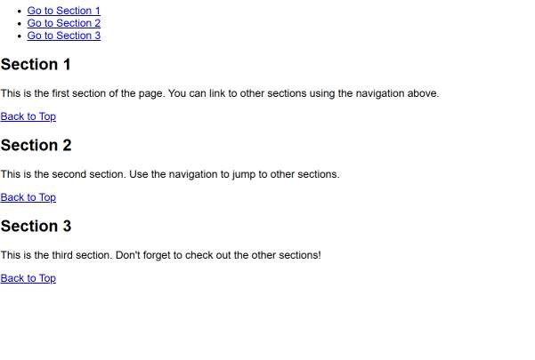

Q23 Write HTML code for including External hyperlinking in a web page.

<html>

<head>

<title>External Hyperlinking Example</title>

<style> body {

font-family: Arial, sans-serif;

} a { color: blue; text-decoration: none;

}

a:hover {

text-decoration: underline;

}

</style>

</head>

<body>

<h1>Welcome to My Web Page</h1>

<p>Here are some useful external links:</p>

<ul>

<li><a href="https://www.wikipedia.org" target="_blank" rel="noopener noreferrer">Visit Wikipedia</a> - A free online encyclopedia.</li>

<li><a href="https://www.github.com" target="_blank" rel="noopener noreferrer">Check out GitHub</a> - A platform for version control and collaboration.</li>

<li><a href="https://www.openai.com" target="_blank" rel="noopener noreferrer">Learn about OpenAI</a> - An AI research organization.</li>

</ul>

<p>Feel free to explore the links above!</p>

</body>

</html>

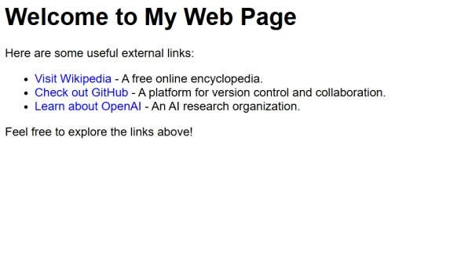

Q24 Write code to show External CSS with HTML code.

<html>

<head>

<title>External CSS Example</title>

<link rel="stylesheet" href="styles.css"> <!-- Linking external CSS -->

</head>

<body> <style> body {

background-color: #f0f0f0; font-family: Arial, sans-serif;

}

h1 { color: #333; text-align: center;

} p { color: #555; font-size: 18px; padding: 20px;

}

</style>

<h1>Welcome to My Website</h1>

<p>This is a simple example of using external CSS with HTML.</p>

</body>

</html>

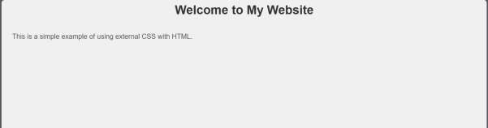

Q25 Write code to show Internal CSS with HTML code.

<html>

<head>

<title>Internal CSS Example</title>

<style> body { background-color:Wite; font-family: Arial, sans-serif;

}

h1 {

color:Red; text-align: center;

}

p {

color:Blue; font-size: 18px; padding: 20px;

}

</style>

</head>

<body>

<h1>Welcome to My Website</h1>

<p>This is a simple example of using internal CSS with HTML.</p>

</body>

</html>

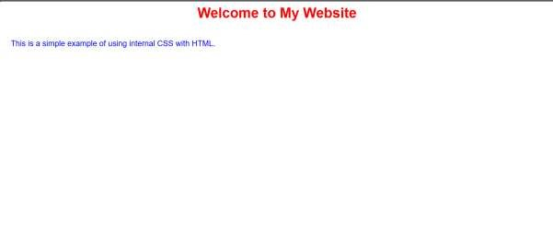

Q26 Write code to show Inline CSS with HTML code.

<html>

<head>

<title>Inline CSS Example</title>

</head>

<body style="background-color: Black; font-family: Arial, sans-serif;">

<h1 style="color:White; text-align: center;">Welcome to My Website</h1>

<p style="color: White; font-size: 25px; padding: 30px;">

This is a simple example of using inline CSS with HTML.

</p>

</body>

</html>

